Grand Canyon University

Project 1 – Visualize ODE With SciPy

Diego Guerra and Ryan Scott

CST-305: Principles of Modeling and Simulation Lecture & Lab

Dr. Ricardo Citro

September 17, 2022

### Responsibilities**:**

Ryan Scott: Python Code Execution, Flowchart, README

Diego Guerra: Documentation, Flowchart

### Specific problem solved:

The current problem that we are solving is finding the data rate of a network using the following equation:

y=-k\cdot\log_2\left(x\right)

Using the “change of base formula” rule that we know about logarithms, we know that:

\log_2\left(x\right)=\frac{\ln\left(x\right)}{\ln\left(2\right)}

Therefore we can write the equation as the following:

y=-k\cdot\frac{\ln\left(x\right)}{\ln\left(2\right)}

The mathematical approach for solving it is by taking the derivative of the bps , and with that derivative we should have the data rate equation. Solving for the equation gives the following equation.

NEW EQUATION

\frac{dy}{dx}=-k\cdot\frac{1}{\left(x\cdot\log\left(2\right)\right)}

With k as the value of 0.4

### The approach for implementation in code + Flowchart:

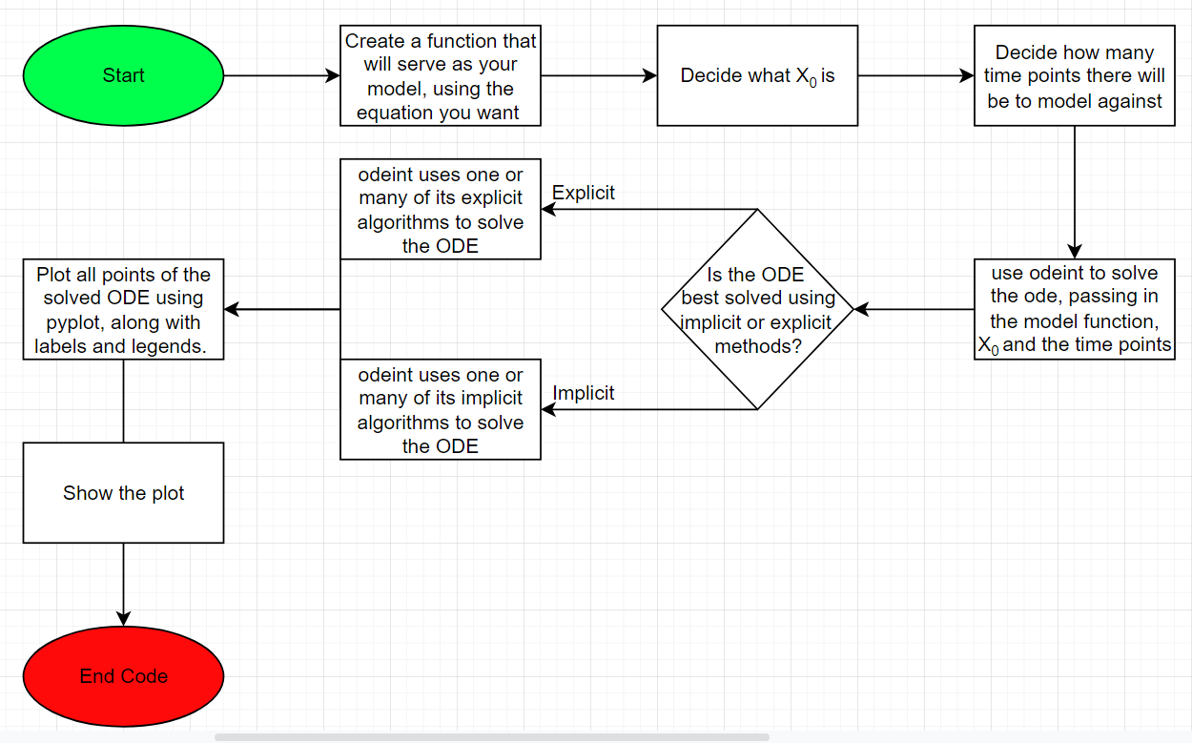

Our first step in graphing this ODE was to take the derivative of the initial equation. Once we had the derivative equation, we created a function to match it. A list of time points was run through the function with odeint, and the graph was generated with matplotlib once we were done.

We used <https://www.derivative-calculator.net/> to verify our solution, both in equation and graphing.

### Screenshots depicting key phases in the program execution:

### 

### References:

<https://apmonitor.com/pdc/index.php/Main/SolveDifferentialEquations>

<http://www.scholarpedia.org/article/Odeint_library>

<http://mason.gmu.edu/~rmorika2/Baud_Versus_Bits_per_second.htm#:~:text=This%20equation%20is%3A,signaling%20levels%20per%20clock%20cycle>.

<https://www.youtube.com/watch?v=jPRUMMA_Ex8&ab_channel=MsShawsMathClass>